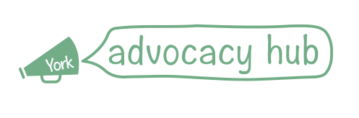
Benefits and Debt Advocacy Volunteer
York Advocacy Hub is a service delivered by York Mind, in conjunction with Cloverleaf Advocacy, to provide 5 specialist advocacy services to people living in York. For more information on our work please visit our website at www.yorkadvocacy.org.uk
We have been successful in securing funds from the Joseph Rowntree Foundation and the City of York Council to deliver a project supporting people to access debt and benefits advice, and are looking for volunteers to work with us until Dec 2019.
Your role would be to help clients to attend meetings with advice agencies and then to put plans into action to alleviate poverty, including attending benefits related assessments and appeals to support people to communicate their wishes and needs. You will not be giving advice directly around benefits or financial matters, but will be providing much-needed one to one support, helping clients find and understand advice and make choices to improve their lives.
We would love to hear from you if you:
- care about people’s rights and making sure they have a voice in the benefits system
- are able to give a few hours of your time a week
- reliable, caring and confidential
- interested in learning more about people’s rights and how to support them in an independent role.
We will provide a full induction and training for volunteers, as well as ongoing 1:1 and group supervision.
How to apply: please visit the following web pages where you can download a copy of our Volunteer Application Form; alternatively you can give the Advocacy Hub a call on 01904 414357 and we will send a form to you in the post,
www.yorkmind.org.uk/volunteering
www.yorkadvocacy.org.uk/about-us/volunteering/
The recruitment process will involve an interview with people delivering the advocacy project, collection of references and an enhanced DBS check.
If you’d like to chat about the role please call Cat Adlam, Service Manager at York Advocacy Hub on 01904 414357.

