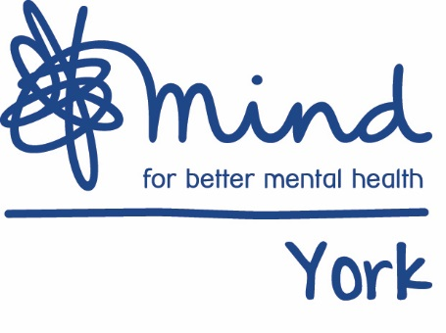

Young People’s Coordinator
Up to 30 hours per week
£21,600 per annum pro rata
Project funded until 31st March 2022

We are seeking an enthusiastic and creative project coordinator to deliver on our recently funded arts based project for young people.

York Mind is a successful mental health charity providing a wide range of services to help support people’s mental health recovery and wellbeing including counselling, an activities programme, training, services for young people and advocacy.

As young persons’ coordinator, you will be part of the young persons’ team, supporting clients aged 8 - 21 through 1-1 and group based activities. We are looking for an individual with a good understanding of the needs of young people, alongside experience of delivering group based and 1-1 support.

For an application pack visit www.yorkmind.org.uk/jobs or if you need support to download an application please ring on 01904 643 364.

If you would like an informal discussion about this post, please contact Rab Ferguson, Young People’s Manager on 01904 666755 or rab.ferguson@yorkmind.org.uk . Your completed application form should be returned to: vacancies@yorkmind.org.uk or posted to York Mind, Highcliffe House, Highcliffe Court, York YO30 6BP

Closing date: 9am Monday 14th October 2019
Interview date: week commencing 21st October 2019

