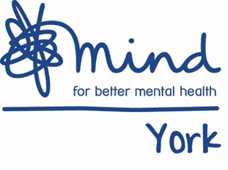
Freelancer Framework - Pre-qualification questionnaire (PQQ)

Section 1: Information about your business

Name and address of organisation

How long trading under this name/previous name

Contact name for enquiries about this PQQ | Name
 | Tel No.
 | Email

Section 2: Business activities
Include: your core business functions; relevant trade or Professional Associations which your business is a part of and; summary of experience relevant to the role of freelancer
Section 3: Quality
Quality Assurance certificates/ Quality Assurance Systems/Quality Marks you use and how it relates to the role of freelancer
Section 4: Insurance Please provide details of your organisations insurance policies in terms of professional indemnity and public liability. Minimum £5,000,000
Policy Type | Expiry date | Insurer | Indemnity Value
Professional indemnity
Public liability
Other (please provide details)

Section 5: Health and Safety
Please provide a copy of your organisations:
- Risk assessment
- Health and Safety Policy or provide confirmation that you will adhere to the York Mind`s Health and Safety Policy and Procedures which can be found at www.yorkmind.org.uk

Section 6: Equal Opportunities
Please provide a copy of your organisations:
- Equal Opportunities policy/ details of practices you have in place or provide confirmation that you will adhere to the York Mind`s Equality and Diversity Policy and Procedure which can be found at www.yorkmind.org.uk

Section 7: Client experience
Please indicate which of the following client groups have you had experience of working with:
Client group | Brief outline of experience
Vulnerable Adults

Vulnerable Young People

Other – please specify

Section 8: Disclosure and Barring Service
Please provide details of your disclosure and barring service certificate. You may be required to obtain an updated DBS certificate if your current certificate is more than 12 month old
Type please specific (Standard/ Enhanced) | Date issued | Certificate number
Section 7: Supporting Statement (max 400 words)
Briefly outline your skills, knowledge and experiences relevant to the role of freelancer (include any specialist areas of expertise)

Please note that taking part in our Framework does not guarantee the offer of a freelance role. However, the Framework will usually be our preferred option when seeking to fill a freelancer position. Please ensure you submit this PQQ to vacancies@yorkmind.org.uk by the submission deadline as late submissions may not be accepted.

Signed

Date

