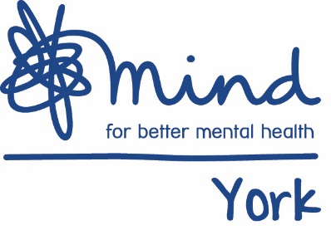

Job Description

Job Title: | Mental Health and Well-Being Trainer
Hours (including working days) | 15 hours per week, over 2 days (to be agreed)
Salary: Pro-rata/full time/part time | Salary: £21,600 - £24,000 pro rata (depending on experience)
Responsible to: | Mark Willis, Training Manager
Responsible for: | N/A
Primary Base: | Highcliffe House, Highcliffe Court, York, YO30 6BP
Aim of the post: | To ensure the timely delivery of existing training packages to a range of learners. To develop training packages/learning interventions and undertake evaluations

Main deliverables:
- To deliver consistent high quality training packages such as Mental Health First Aid, Suicide Prevention, Stress Management and Resilience Training
- Create content for standard and bespoke courses, updating these based as necessary
- To actively promote the training opportunities offered by York Mind
- To manage enquiries about York Mind training interventions
- To deliver training in accordance with the York Mind delivery plan and income targets

Main duties:
Key Responsibilities
- To develop and deliver existing training packages including preparation of topics and materials
- To create content for standard and bespoke courses
- Support learners to engage with the learning material
- Analyse feedback from training courses and making suggestions for improvements
Client Focussed:
- To work collaboratively with existing and potential clients; undertaking initial assessment of requirements
- To plan, facilitate and evaluate training interventions
- To review client feedback and monitor progress throughout the training intervention
Administrative:
- Pre and post training administration
- To support the Training Manager with production of performance reports
- To support the Training Manager to promote training interventions and manage enquiries
- To ensure that all necessary paper work is completed in a timely and accurate manner
Volunteers:
- To support volunteers

Other:
- Undertake any other duties that may from time to time be reasonably required

Essential qualifications: | At least one year`s experience of training delivery, preferably delivering mental health related interventions  - A recognised training qualification

The post holder will carry out any other duties, which are within the scope, spirit and purpose of the job as requested by the line manager.

If duties and responsibilities change, the job description will be reviewed and amended in consultation with the post holder.

