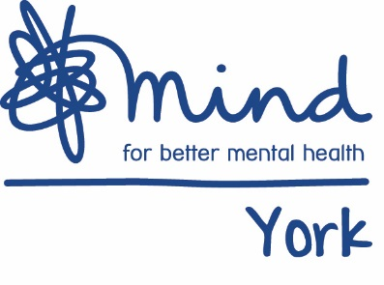

Develop your potential...

Volunteer Application Form (please write clearly in black ink or type)

Title of role applied for:
Ref:

Personal details (BLOCK CAPITALS PLEASE)

Surname:  Surname: | Forenames:
Address: | Tel No. (Home):
 | Tel No. (Business):
 | Mobile No:
 | E-mail address:
 | National Ins. No:

How did you hear about us? ………………………………………………………………………….......
Volunteering Opportunities (please tick one area that you would be interested in)

 | Advocacy |  | Staying Ok Project
 | Activities |  | Training
 | ATI |  | Young People’s Counselling
 | Counselling |  | Young People`s Project
 | Fundraising |  | Other (please specify)

About you

York Mind asks all volunteers for a minimum 6 month commitment for all roles except fundraising. Do you want to volunteer …

On a regular basis (please state what day and hours)

As a ‘one off’

Occasionally (please state when you would be available)

Are you likely to be available for:

6- 12 months
Ongoing
Other (please specify)

Please say briefly why you are interested in volunteering with York Mind?
Please include what you would like to gain from volunteering and what your motivation is?

Please briefly explain why you think you would be suitable as a volunteer with York Mind?
Relevant Experience

Please tell us about any experience which you feel would be relevant to this volunteer role. You can include life experience, including experience of mental health and volunteer roles. You may find it helpful to refer to the volunteer role description.

Please give details of any other experience, education or training which you feel would be helpful to you as a volunteer in this role at York Mind?

Hobbies and Interests

What are your hobbies and interests?
EQUALITY ACT 2010
If invited to interview you will be asked if you require any reasonable adjustments in order to attend an interview. Where possible these will always be accommodated. Any offer of a voluntary role with York Mind will be subject to the receipt of satisfactory references.

REHABILITATION OF OFFENDERS ACT 1974
Please note: Depending on the nature of the post you are applying for, any subsequent offer of employment may be subject to a criminal record check. If a criminal record disclosure is required, it is exempt from the Rehabilitation of Offenders Act due to the nature of our work. This means “spent” convictions, cautions, reprimands or final warnings will be disclosed along with current convictions and cautions.

Please declare any unspent cautions and convictions (and “spent” cautions and convictions if the post is exempt) on a separate sheet and tick this box if doing so

Other information

Names and addresses of two people who we can ask for a reference. They should have known you for at least one year and be able to speak about your suitability as a volunteer at York Mind. They should not be related to you or living with you.

Do you consent to references being sought prior to interview? YES/NO
Tel No:  Email Address: | Tel No:  Email Address:
Please state maiden name if applicable
Declaration

By signing this form I declare that the information given is true and correct. I accept that supplying false or misleading information or knowingly withholding information may result in any subsequent volunteering role offer being withdrawn. .

Signed …………………………………… Date ……………………..……Name ………………………………………

Thank you for completing this application. Please return to: volunteering@yorkmind.org.uk or York Mind, Highcliffe House, Highcliffe Court, York, YO30 6BP

Data Protection Act 1998
The use of information provided on this form will comply with the requirements of the above Act. It may be processed by computer and is required for operational, managerial information and associated purposes relevant to the maintenance of the organisations systems. Such data may also be used to produce anonymous statistics.

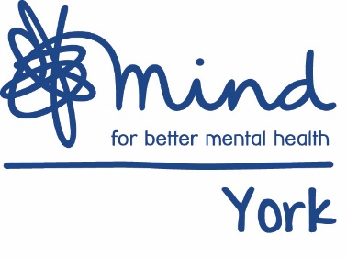

Recruitment Monitoring Form (Confidential)

York Mind is committed to taking a proactive approach to promoting equality in all aspects of our services including volunteering and employment. We would appreciate if you could complete the equality monitoring questions below. This will help us in monitoring the fairness and effectiveness of our service delivery, employment and volunteering practices and to develop future polices and services. You are under no obligation to provide the information requested and it will not make any difference to the service you receive if you do not answer them. However the more information we collect, the more effective our equality monitoring will be. York Mind is committed to keeping your information private and secure. Any information given will be treated in the strictest confidence in accordance with the Data Protection Act 1988, and will be used solely for the purpose of monitoring.

Gender Male Female Prefer not to say
Are you married or in a civil partnership? Yes No Prefer not to say
Age 16-24 25-29 30-34 35-39 40-44 45-49 50-54 55-59 60-64 65+ Prefer not to say
What is your ethnicity?
Ethnic origin is not about nationality, place of birth or citizenship. It is about the group to which you perceive you belong. Please tick the appropriate box

White
English Welsh Scottish Northern Irish Irish
British Gypsy or Irish Traveller Prefer not to say
Any other white background, please write in:

Mixed/multiple ethnic groups
White and Black Caribbean White and Black African White and Asian
Prefer not to say Any other mixed background, please write in:

Asian/Asian British
Indian Pakistani Bangladeshi Chinese Prefer not to say
Any other Asian background, please write in:

Black/ African/ Caribbean/ Black British
African Caribbean Prefer not to say
Any other Black/African/Caribbean background, please write in:

Other ethnic group
Arab Prefer not to say Any other ethnic group, please write in:
Do you consider yourself to have a disability or health condition?
Yes No Prefer not to say

What is the effect or impact of your disability or health condition on your ability to give your best at work? Please write in here:

The information in this form is for monitoring purposes only. If you believe you need a ‘reasonable adjustment’, then please discuss this with your manager, or the manager running the recruitment process if you are a job applicant.
What is your sexual orientation?
Heterosexual Gay woman/lesbian Gay man Bisexual
Prefer not to say If other, please write in:

What is your religion or belief?
No religion or belief Buddhist Christian Hindu Jewish
Muslim Sikh Prefer not to say If other religion or belief, please write in:
What is your current working pattern?
Full-time Part-time Prefer not to say

Do you have caring responsibilities? If yes, please tick all that apply
None Primary carer of a child/children (under 18)
Primary carer of disabled child/children
Primary carer of disabled adult (18 and over) Primary carer of older person
Secondary carer (another person carries out the main caring role)
Prefer not to say
Develop your potential...

