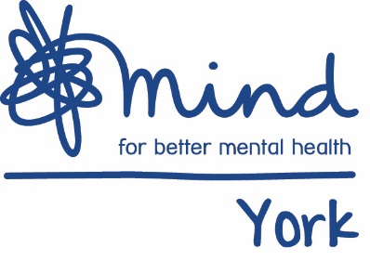

Job Description

Job Title: | Independent Advocate – (qualified or unqualified)
Hours (including working days) | 37.5 hours per week – Fixed Term until 31 March 2022
Salary: Pro-rata/full time/part time | £22,000 for qualified advocates.  £21,600 for unqualified advocates  Please note you do not need an advocacy qualification to apply for this role
Responsible to: | Project Co-ordinator
Responsible for: | N/A
Primary Base: | York
Aim of the post: | To provide an independent and confidential advocacy service to people in York, and the surrounding area

Main deliverables:

To provide an advocacy service to people who fall within the eligibility criteria in line with the relevant codes of practice and best practice guidance. This will include Independent Mental Capacity Advocacy (IMCA), Independent Mental Health Advocacy (IMHA), Care Act Advocacy (CA), NHS Advocacy, Relevant Person’s Representative role (RPR) and General Advocacy.
- To deliver all these advocacy streams in a flexible and efficient way

To manage a fast paced caseload of clients and maintain accurate case notes, files and records pertinent to the work you are doing with clients

To work collaboratively and in partnership with other agencies

Main duties:
- To work within the aims and objectives of York Mind
- To work within the advocacy principles and the aims and objectives of York Mind to the benefit of those using our services.
- To keep clear and unambiguous records in writing and in-line with service quality standards within York Mind, and respect all aspects of clients’ confidentiality.
- To ensure a commitment to quality management in York Mind
- To work within and uphold the policies and procedures of York Mind and advocacy specific procedures.

B) Provide advocacy services
- To provide one-to-one advocacy for people accessing York Advocacy Hub’s services, in a flexible and efficient manner.
- To manage a fast paced caseload of clients and maintain accurate case notes, files and records pertinent to the work you are doing with clients.
- To engage in further training relevant to the role as identified by your line manager.
- Maintain accurate records of expenses expenditure in line with York Mind’s policies and procedures.
- To participate willingly in regular line-management meetings and team meetings.

- Support the service within a team of advocates and a wider partnership
- Promote the right to advocacy to clients, their families and friends, and stakeholders through talks, meetings and disseminating information.
- To attend team meetings, supporting colleagues as part of a peer-case review process.
- Contribute to the sharing of information within the team such as common themes for monitoring reporting, service delivery issues and general service development.
- To engage with wider York Mind and York Advocacy Hub service teams where appropriate such as attending team away days or information events.

- Legislation
- To keep up to date with key legislation affecting the post.

The post holder will carry out any other duties, which are within the scope, spirit and purpose of the job as requested by the York Advocacy Hub Managers.

If duties and responsibilities change, the job description will be reviewed and amended in consultation with the post holder.

Essential qualifications: | N/A

